Part 2 - Deploying a Fabric CI/CD Project
Part 1 of this whitepaper taught you about the fundamental concepts and tools used to implement CI/CD in Fabric. In Part 2, you will work through all the steps of starting a new project with a Fabric solution and , it is time to work through setting up a new projects.
Every Fabric CI/CD project starts with a Fabric solution. If you have an empty workspace, you can begin to prototype the solution. Once the Fabric solution prototype is approved and you get the green light to move ahead to deploy the solution to production, there are several steps you should go through.
- Plan the Application Lifecycle
- Set Up Project Infrastructure
- Build a development process for contiguous integration
- Build a release process for contiguous deployment

Plan the Fabric CI/CD Project Lifecycle
Start with planning details about the solution and the number of environments you need beyond the production environment for development and testing. You need to plan on how GIT will be used in the development process. This involves selecting a GIT provider and adopting a branch strategy. The plan should also include how to work with feature branches and feature workspaces. Finally, you need to plan how you are going to build the project's release process.

Plan the Fabric solution
You can think of a Fabric solution as a set of workspace items that have been designed to work together. The idea is that these workspace items as a whole provide value in terms of data analytics of AI. In a simple scenario, all the workspace items in a Fabric solution can be deployed to a single workspace.
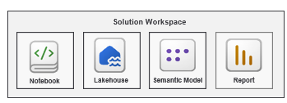
Now a Fabric solution with a medallion architecture can be more complicated.
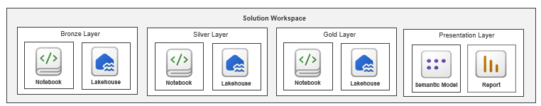
A Fabric solution can also be deployed across two or more workspaces. To keep things simple, this article will start by examining a Fabric solution deployed to a single workspace. This article will revisit the topic of creating a Fabric CI/CD project based on a Fabric solution that is spread across multiple workspaces later in the chapter.
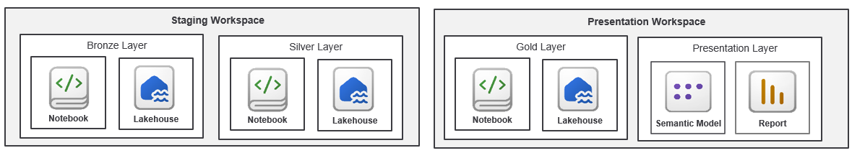
What should you do when you want to deploy a Fabric solution using Fabric CI/CD support? That's when you need to create a Fabric CI/CD project in which the solution's workspace items are replaced across multiple workspaces as shown in the following diagram.

Plan the Environments
What environments to you need. What Azure resource do you need for each environment.
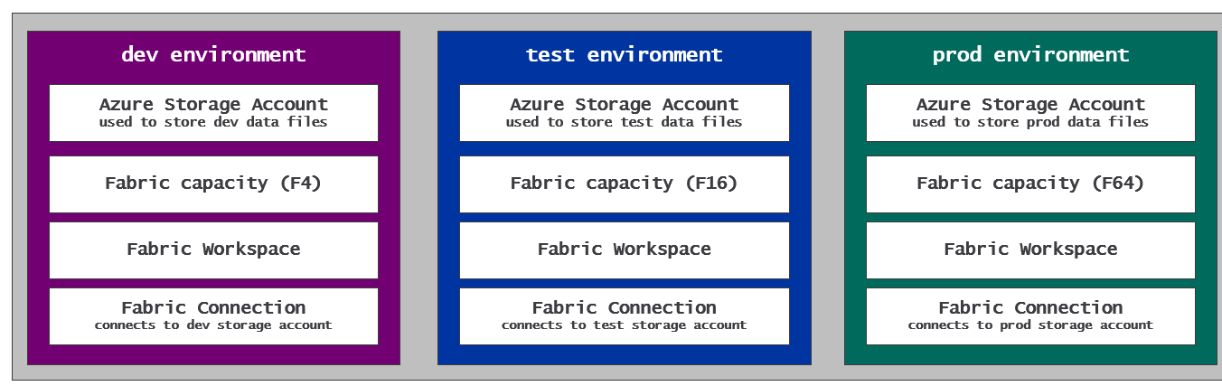

Plan a GIT Branching Strategy
Another Important distinction when designing a branching strategy is to determine which branches are long-lived and which one are only temporary. The integration branch is a long-lived branch as it will be created at the start and will have a lifetime as long as the CI/CD project itself. Branches up the hierarchy to main are also long-lived branches. In the two diagrams above, the main branch, test branch and dev branch are examples of long-lived branches.
Feature branches are typically short-lived branches. For example, a feature branch is created when it's time to creating or update a workspace item such as a notebook or a report.
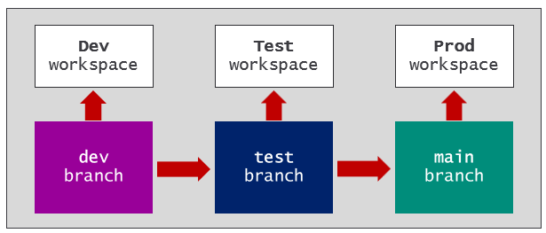
Talk about different environments with different environment settings.
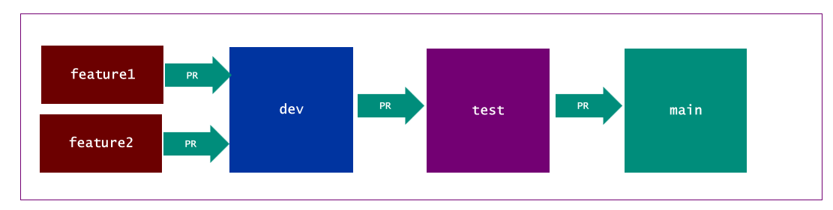
Automation pipelines run automated builds to run tests to analyze code

Plan The Development Process
Edit in workspace
Edit in branch

More Info
- Content lifecycle management
- Develop content and manage changes
- Validate Content

Plan The Release Process

Setting Up the Infrastructure for a Fabric CI/CD Project
Fabric supports both workspace items and tenant-level items. Examples of tenant-level items include workspaces, connections, gateways and deployment pipelines. Remember that Fabric GIT integration support focuses on deploying and updating items create at workspace scope. That means use must use other tools and techniques for managing CI/CD for tenant items.

Given our choice of branching, we can start to design the infrastructure. You need to create a workspace for the three long-lived branches which are dev, test and main. You will also need one or more Fabric capacities to associate with the workspaces. For example, you might create a Fabric capacity using a smaller size such as a F4 for the dev workspace and for feature workspaces. For the test workspace, you can use a larger capacity size such as a F16. There might also be an opportunity to pause the test capacity whenever you are not actively engaging in testing. Finally, you can use a larger size capacity for the prod workspace such as an F64.
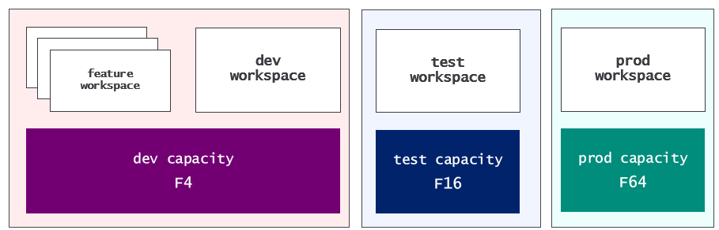
You will also need to

Sss
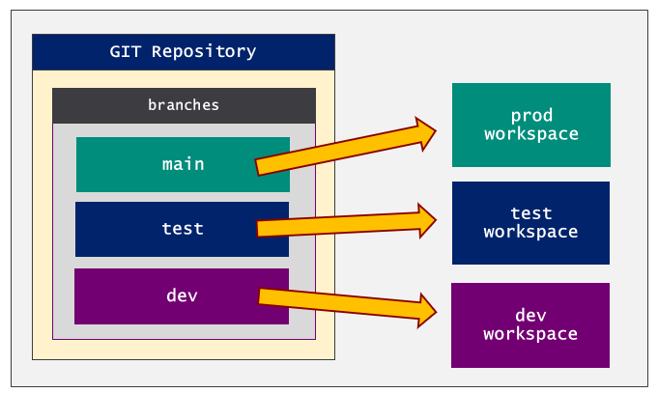
In order to connect a workspace to a GIT branch, you need to create a Fabric connection. If you are using a repository in Azure DevOps, you need to create a connection using the AzureDevOpsSourceControl connector. If you are using a GitHub repository, you can create a connection using the GitHubSourceControl connector.
Sss
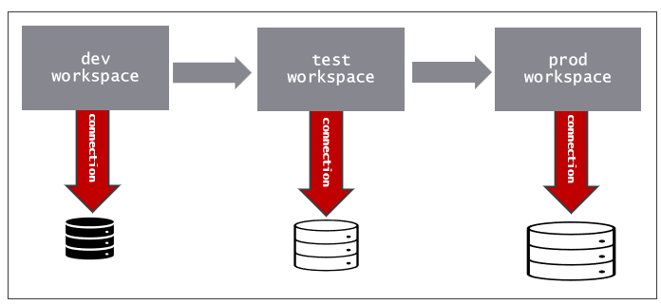
Ss
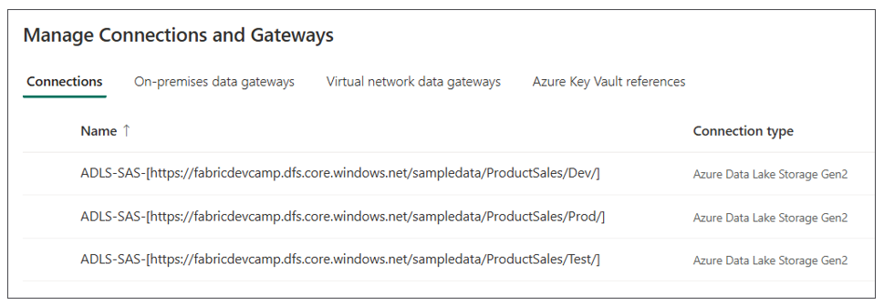
List
- Git Repository
  - Create Azure DevOps project
  - Create GitHub repository
  - Set up long-lived branches (main, test, dev)
  - Mark dev branch as default branch
- Create Fabric connection to Git Repository
- Create Fabric Capacities
- Create Fabric Workspaces for long-lived branches
Quick description of ClickOps and why it is bad,
You could automate infrastructure deployment write code to
You can also use Terraform.

Create Project Infrastructure using Terraform
Infrastructure ID involves creating items that need to be created and configured a single time in the initial deployment. Examples of infrastructure components include servers, containers, databases and connections, These infrastructure components are created during the initial deployment.
After the infrastructure components has been created, the lifecycle process can begin. Application CI/CD now starts and continues as the infrastructure CI/CD has been completed to be
Add section about the difference between Workspace Item CI/CD and Data CI/CD. Data CI/CD is about building processs and running jobs to ingest and transform data and to continually keep data up to date. CI/CD workflows should not contain logic for data processing. Instead, you should abstract out ETL logic by building it into workspace items such as notebooks, pipelines, copy jobs and dataflows.
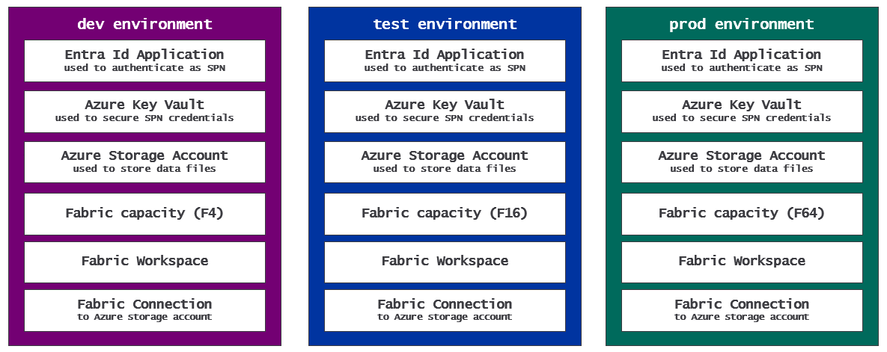
At the start of a Fabric CI/CD project, there are one-time provisioning operations that just need to be completed once.

Infrastructure CI/CD is different from CI/CD with workspace items. Infrastructure CI/CD involves provisioning platform level resources. For example, infrastructure CI/CD in general application development might involve providing resources such as networks, load balancers or databases. In Fabric, infrastructure CI/CD involves provisioning platform-level items such as workspaces, capacities and connections.
Fabric provides a set of workspace items that can be created within the scope of workspace. Fabric also provides platform items which are not created at workspace scope. Instead, platform items are created within the scope of the current Entra Id tenant. Examples of these platform items include Workspace, Capacity and Connection.

Create the GIT Repository
You can implement CI/CD using a cloud-based service that supports GIT-based repositories such as Azure DevOps, GitHub or GitHub Enterprise. Once you have created a new repository for CI/CD purposes, you must then decide the best way to create and managed the branches. The software industry has adopted several popular strategies for managing GIT branches and workflows such as Gitflow, GitHub Flow and Trunk Based Development.
We will use GitFlow in this walkthrough.
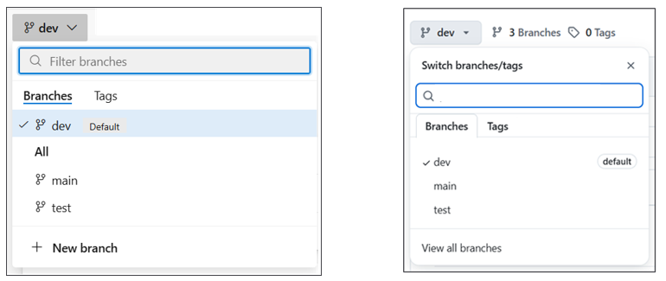
In this branching strategy, there will be three long-lived GIT branches which are main, test and dev. The three workspaces associated with long-lived branches will also be long-lived. That means they need to be created at the start of the project and will remain for the project's lifetime.
Feature branches and feature workspace are not long lived. Feature branches will be created on an as-needed basis and will be deleted as soon as the developer has completed work on that feature and submitted changes using a pull request. In some scenarios, it makes sense to create and delete feature workspaces along with their associated feature branches. However, it is also keep feature workspaces and switch them between feature branch. This topic will be revisited after we walk through the initial project setup process.
Selecting the best branching strategy for a particular project depends on several factors including the size of the team, the complexity of the project and the frequency with which changes must be promoted into production.
Additional Resource
- Creating project and repositories in Azure DevOps
- Adopting a GIT branching strategy in Azure DevOps
- Creating repositories in GitHub
- Adopting a GIT branching strategy in GitHub

Connect Workspaces to the GIT branch
Create a GIT Source Control Connection
More information
- Managing your personal access tokens I GitHub

Deploy the Solution to Release Branch

Create a Variable Library to Parameterize Connections
nn

Sssss
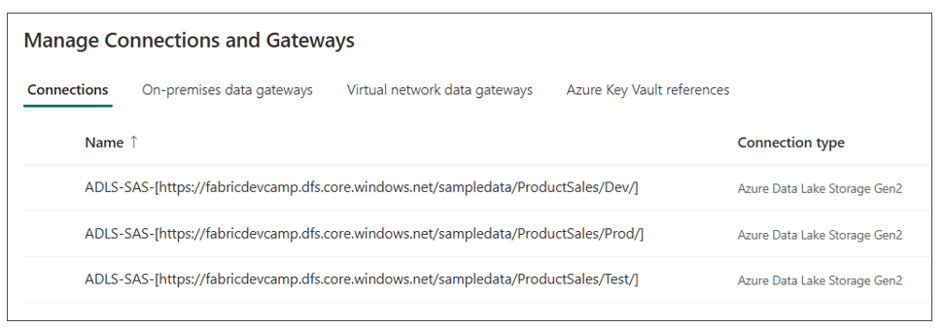

Build the Development Process

Managing Feature Branches and Feature Workspaces

The 'Edit in Workspace' Workflow

The 'Edit in Branch' Workflow

Managing feature branches and feature workspaces
When implementing CI/CD for a Fabric solution, you can use a GIT service such as Azure DevOps or GitHub just like when implementing traditional CI/CD for general application deployment. However,
Microsoft Fabric is different because it focuses on data analytics solutions built using Fabric workspaces and workspace items. With Fabric CI-CD, you need a create a separate workspace for each stage such as dev, test, prod and you also need to create a workspace for each new feature. Traditional CI/CD optimizes for deploying code and services, while Fabric CI/CD is designed around deploying workspace items such as lakehouses, notebooks, semantic models and reports. The pipeline is less about building and testing applications and more about versioning and promoting workspace item definitions.
How do we get things set up at first. Image the dv workspace already has a set of workspace items that represent a Fabric solution. You can
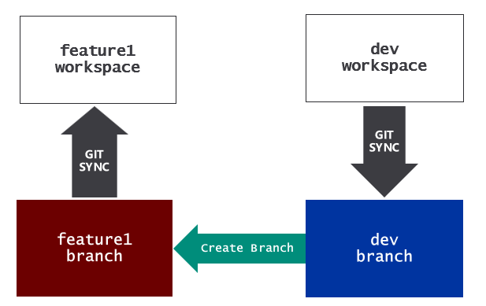
The GIT sync process recreates all the workspace items. However, it doesn’t always do all that is required to setup the feature workspace. You might have to run fix up code to create connections and bind them to semantic models and other dependencies .
Once the feature workspace is set up, you can take make changes by editing and modifying workspace items in the browser. Update code in notebook. Edit the layout of a report. When you’re done, you can sync changes from the workspace back to the feature branch. After that, you can push changes from the workspace back to the feature branch. After that, you can create a pull request to merge changes back to the dev branch.
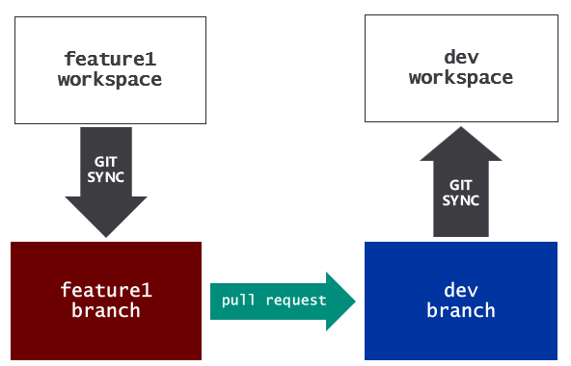
As you’ve seen, you can keep things simple by modifying workspace items using the browser in the feature workspace. However, for developers that prefer working directly with code, there is another option.
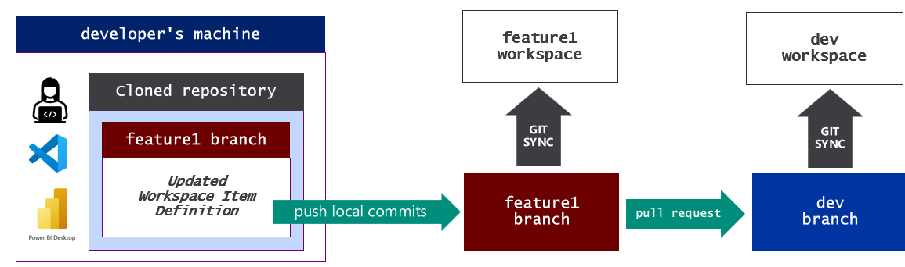
In effect, the developer is making changes directly to the files in the feature branch. However, the developer likely wants to test those changes in the feature workspace. Therefore, it is necessary to pull the changes from the dev branch into the dev workspace.

Let’s walk through a basic example of implementing CI/CD using the GitFlow branching strategy. The GitFlow strategy will always involve a main branch, a dev branch and feature branches. It also might involve release branches and hotfix branches.
The main branch holds the production-ready code that can be deployed to the production environment. The dev branch is the place where all changes will be merged. Changes that have been merged to dev will go through a validation and approval process. Once the changes that have been merged into dev have been approved, theses changes can be promote to main.
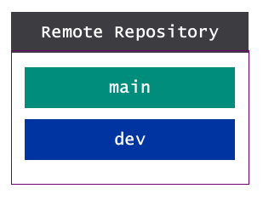
Let’s walk through the steps involved when a developer needs to add or modify application code. The process is started by creating a new feature branch which is initially a copy of the dev branch. A developer can clone the feature branch to create a copy of the files on the developer’s local machine. This allows the developer to begin writing and testing changes.
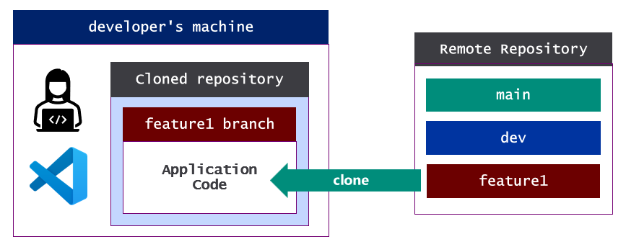
Developer commits changes and pushes then back to remote feature branch.
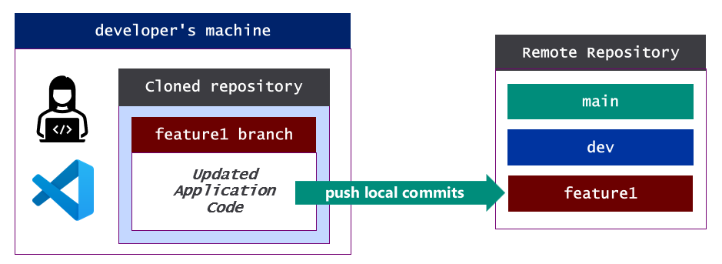
At this point the feature branch contains changes that need to be merged into the dev branch. That brings us to our next topic which is pull requests.
Additional Resources
- Learn about working with branches in Azure Dev Ops
- Learn about working with branches in GitHub

Building a development process workflow
Who are the developers? In traditional CI/CD, these are the people making updates to application code written in programming languages such as Java, C#, JavaScript and TypeScript.
Who are the people we refer to as 'developers' in a Fabric CI/CD project? It could be a professional developer, but it could also be people with expertise with some type of workspace items. These people might not have any experience working woth code directly.
It some cases the people updating workspace items will not be "developers". Report designer just works with UI. Pipeline author

Merging changes using pull requests
In GIT-based system, developers use pull requests to merge their changes from one branch to another. When you create a pull request, you are creating a proposal to merge a set of changes from one branch into another. In most cases, the will involve an approval process that requires interactive participation on the point of humans. This adds in quality control.
Once a pull request is approved, the changes for the pull request are automatically merged into the target branch. Pull requests are used to merge changes from feature branches to the dev branch. Once changes in the dev branch are ready for production, a pull request is created to promote those changes from the dev branch to the main branch.
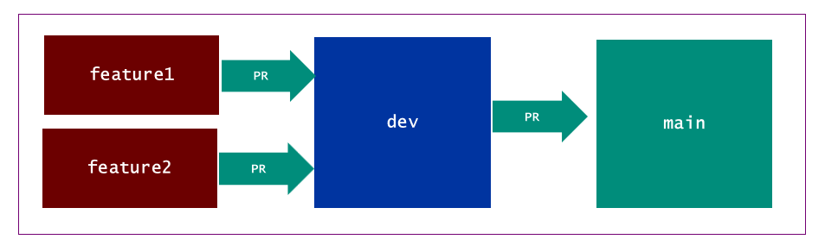
Here is what the high-level process looks like from the perspective of commits and merges

At completion of the PR, the changes in the feature branch are merged to dev and can be tested with all the other code that have been merged into that branch. Once the team is happy with the changes testing in dev has .
TO DO: talk about merge conflicts and techniques for resolving them
Additional Resources
- Learn about create pull request ub Azure DevOps
- Learn about working with branches in GitHub
- Learn how to resolve merge conflicts

Build a Release Process
Here is where we will go
- Release process with deployment pipelines, variable library and (when needed) deployment rules
- Release process triggered by pull request with GIT integration used to synchronize workspace
- Release process triggered by pull request with fabric_cicd library used to synchronize workspace
- Release process where fabric_cicd library used to deploy from single branch to dev, test and prod
- Release process for ISV multitenancy pattern where fabric_cicd library is used to deploy and update from single branch to any number of tenant workspaces

Option 1: Deployment Pipelines

Option 2: Building a Release Process using GIT Integration

Option 3: Building a Release Process for GitFlow using fabric_cicd

Option 4: Building a Release Process for Trunk-based development using fabric_cicd

Option 5: Building a Release Process for multi-tenant development using fabric_cicd

